I just
NCMA Dayton Chapter
CHAPTER
EVENTS

Dayton NCMA Bagels & Business

False Claims Act:

An Overview and Tips for Reducing Exposure

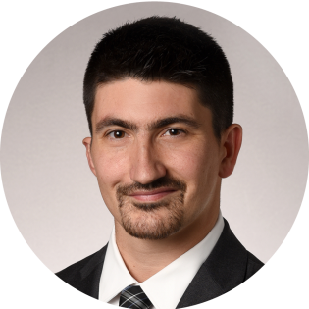
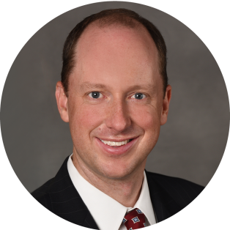
Tuesday, April 2, 2019
7:30am - 8:30am, Registration begins at 7:00am
Location: Hilton Garden Inn, 3520 Pentagon Park Blvd
Cost: $7/members; $10/non-members
Bagels, pastries, coffee, water and juice will be provided.
Register at www.daytonncma.org

Topic: False Claims Act: An Overview and Tips for Reducing Exposure

Presentation by: Patrick M. Hagan, Partner, Dinsmore & Shohl LLP
Tony M. Busch, Associate, Dinsmore & Shohl LLP

Patrick M. Hagan, Esq.
Pat is a litigator who focuses his practice on complex civil litigation, including False Claims Act and environmental litigation. In addition, he has led internal investigations for major government contractors and has coordinated legal and public relations responses on behalf of clients when their reputations are at stake.

In particular, he has extensive experience representing government contractors and health care providers accused of fraud in all phases of cases under the False Claims Act, including cases involving contracts with the Department of Energy and Department of Defense and cases involving alleged Medicare and Medicaid fraud. He has led internal investigations of potential whistleblower complaints, assisted clients in responding to grand jury and state and federal agency subpoenas, negotiated settlements with the Department of Justice, and coordinated litigation in both intervened and non-intervened False Claims Act cases.

Specifically, Pat has successfully represented a client in a unanimous United States Supreme Court decision, Allison Engine Co., Inc. v. United States ex rel. Sanders, narrowing the scope of liability under the federal False Claims Act; negotiated a favorable settlement on behalf of a Department of Energy contractor in an action brought by the Department of Justice seeking damages and civil penalties under RCRA and the False Claims Act in connection with the investigation and remediation of TCE groundwater contamination at a National Priorities List site in Kentucky; obtained dismissal of a False Claims Act case in the Northern District of Georgia that was affirmed on appeal by the Eleventh Circuit; and obtained dismissal of a False Claims Act case in the Western District of Pennsylvania.

He also has experience counseling clients regarding the legal and public relations issues associated with responding to data breaches and defamation and in handling litigation on behalf of financial institutions, including securities and ERISA class actions.

Tony M. Busch, Esq.
Tony assists for-profit and not-for-profit government contractors and subcontractors of all sizes on a range of legal matters. His experience includes four years of involvement in the government contracting industry as an analyst at U.S. Central Command in Tampa, FL, and his counsel includes answering FAR and DFARS compliance questions, resolving contract disputes under the Contract Disputes Act, litigating bid protests before the Government Accountability Office (GAO), False Claims Act defense, and investigating the effect of export controls and sanctions on clients’ business plans. His experience is heavily concentrated in the aerospace and defense industry, but his work has spanned other sectors, including international aid, information technology, and construction.

